

Owner X: Mobile and Desktop Versions

Table of Contents

Owner X: Mobile and Desktop Versions 1
How to use this guide 2
GETTING STARTED 1
App download and installation 1
Owner desktop access 1
Logging In 2
DASHBOARD 2
Dashboard Menu Options 4
Reservations 4
Availability Calendar 4
Work Orders 6
Reports 9
Service Tasks 14
Attachments 16
More info 17
MAKE RESERVATION 18
APPLY COUPONS AND DISCOUNTS 18
NEWS 18
CONTACT US 19
SETTINGS 19

GETTING STARTED

App download and installation

The app is available for download for Apple and Android devices under the name Owner X.



Follow your phone’s instructions to install the app.

Get in touch with us if you experience any issues during the process.

Owner desktop access

Besides managing your home through your mobile device, you may also login from a desktop by navigating to https://ownerx.streamlinevrs.com/
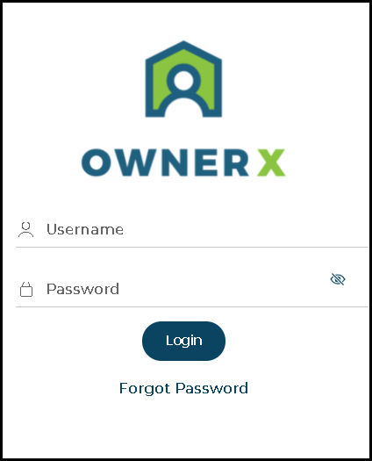
FIGURE 1: LOGIN SCREEN

Logging In

The Login Now screen is the first screen you will see.

You will use your Streamline Login/Username and password to log in, as provided in the access email.

NOTE: The same user id and password will work with the Owner App and desktop access. Get in touch with us if you have any issues logging in.
!

DASHBOARD

The Dashboard is the first screen you will see after logging in.

It presents a drop-down menu where you can select the Property you want to work with as well as the unit’s management tools.


Note: Only your Active units will show in this area. Reach out to us if you notice a home is missing.

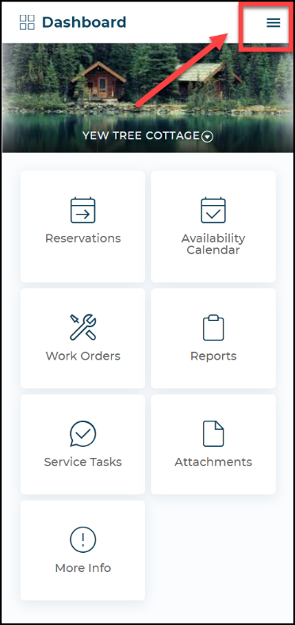  Figure 2: App view | 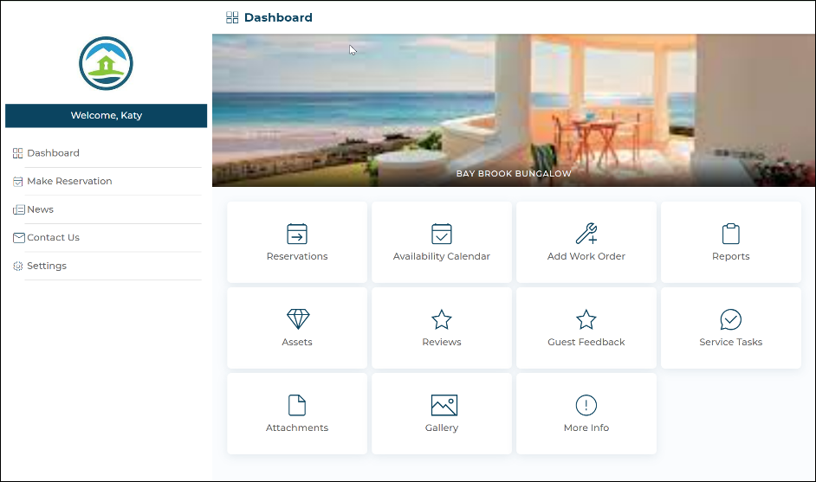  Figure 3: Desktop module view

- View your Reservations for the unit’s
- Check and block that unit. Availability Calendar.
- View and add Work Orders.
- Access some unit Reports.
- View any attachments added to the unit
- View and add unit Service Task.
Note: Not all the management tools shown above may be available, as these depend on our system setup. Reach out to us if you have any questions.

In the App, clicking on the Menu icon on any of the screens will open the Main Menu:

Dashboard Menu Options

Reservations

In this area you will be able to view reservations and modify or cancel your future Reservations.
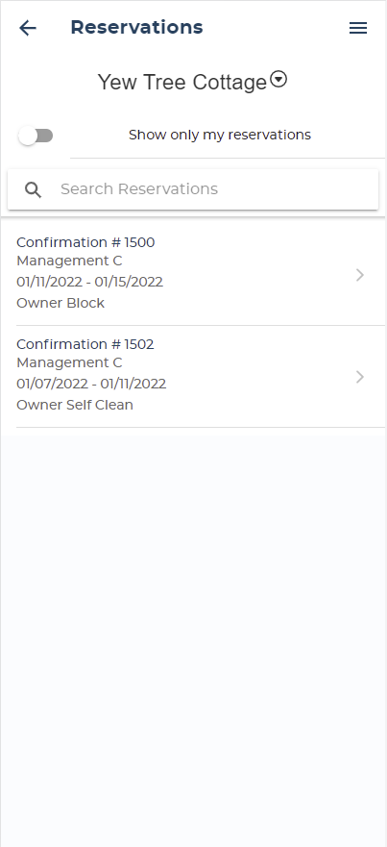  Figure 4: dashboard reservations | 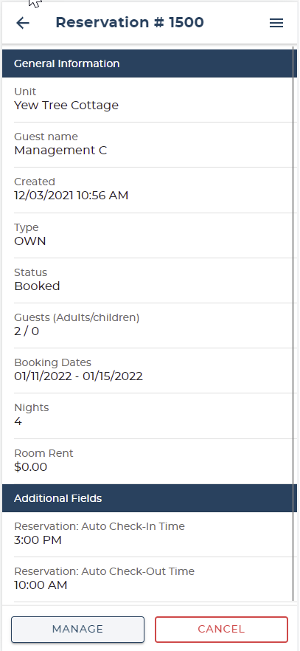  Figure 5: reservation details

Availability Calendar

Use the Availability Calendar to easily view the unit’s availability, make reservations or create Owner Blocks. This interactive calendar with simple data gathering process enables easy unit management.

You can scroll through monthly calendars to view the unit’s occupancy.

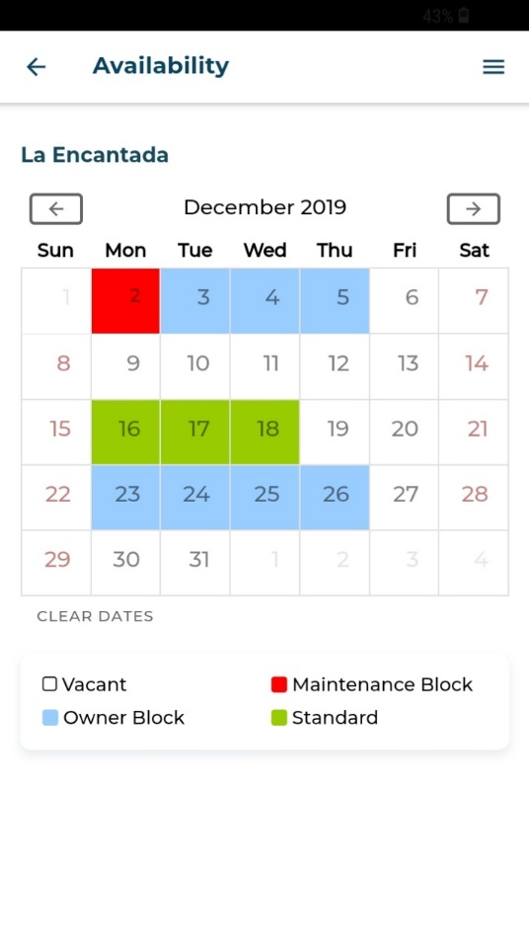
Steps to make Reservation
Figure 6: Availability calendar

- Select the reservation type.
- Select [Check In]. and [Check Out] dates in the Calendar.
- Enter the remaining reservation information.
- Select [Make Reservation]
- View confirmation screen
.
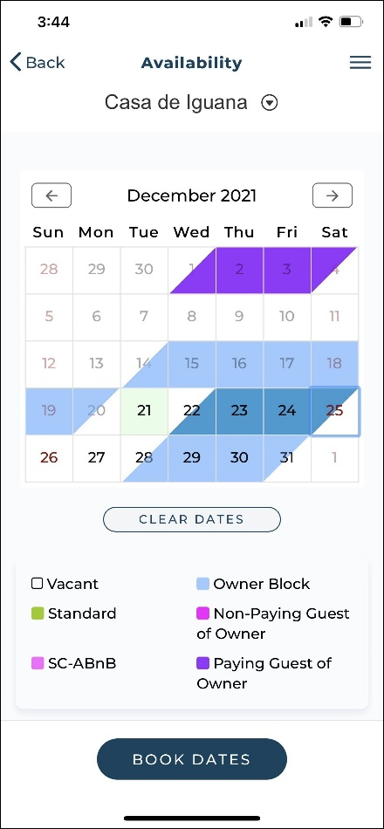  Figure 7: check-in and check-out dates | 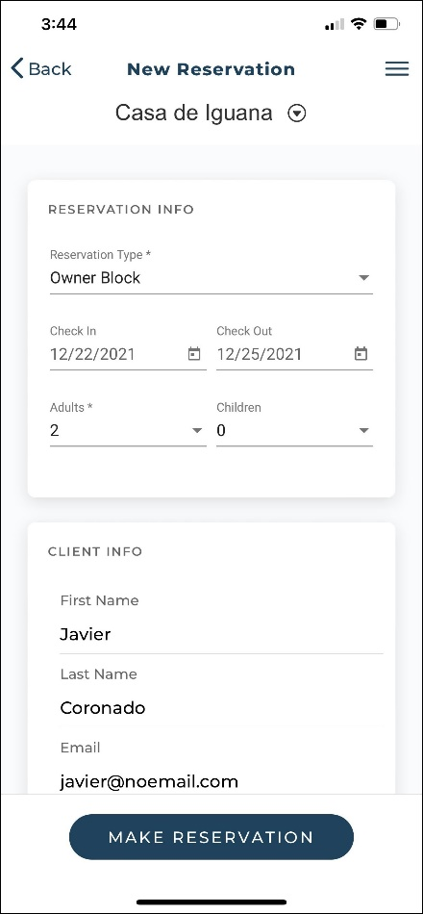  Figure 8: reservation details | 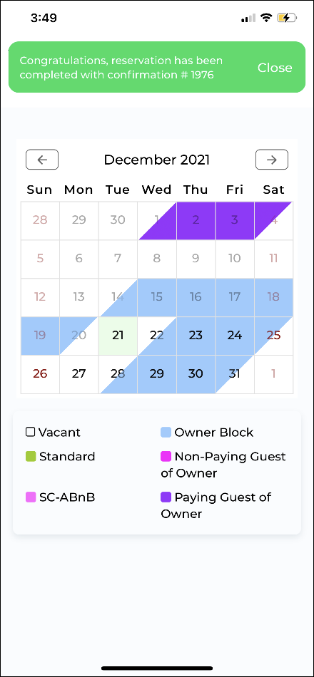  Figure 9: confirm reservation

Work Orders

In this area, you will be able to view the unit’s Work Orders as well as add new ones:

The unit’s Work Orders will be sorted in Pending, Active and Completed status.
The main view will be Active. Work Orders marked as Critical will be positioned at the top of the list.

Note: You will not be able to modify the unit’s Work Orders from this
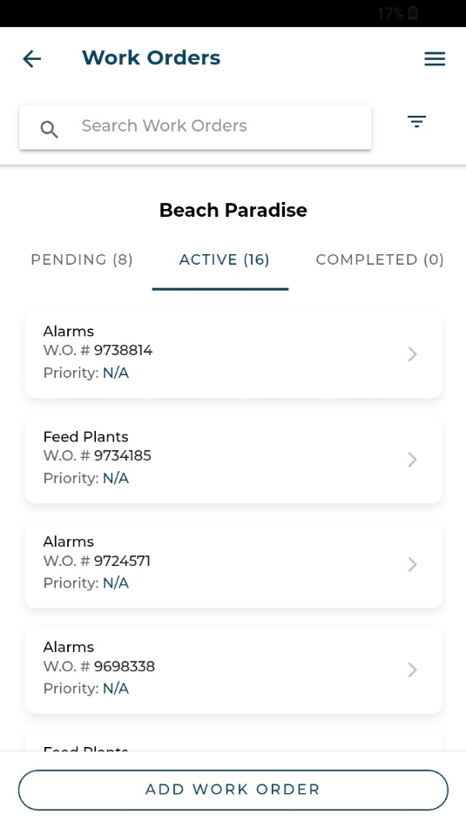
screen. Once added, work orders will be “closed” to modification.
Figure 10: work orders

Add Work Order

You can also add work orders.
The process to Add a Work Order is simple (Figures 11 – 16)
- Enter a Title.
- Select a Priority.
- Enter a Description.
- Add photos if required.
- Select [Create Work Order] and confirm.

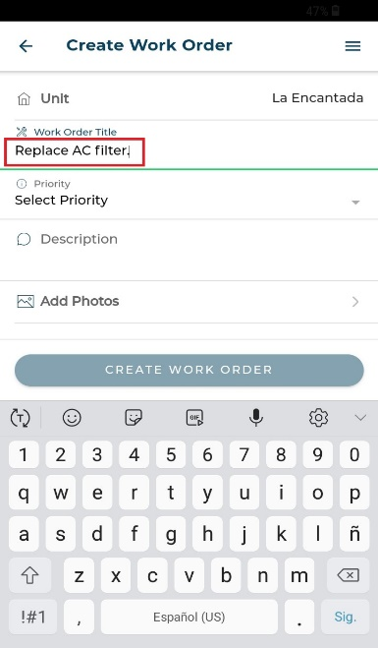  Figure 11: enter title | 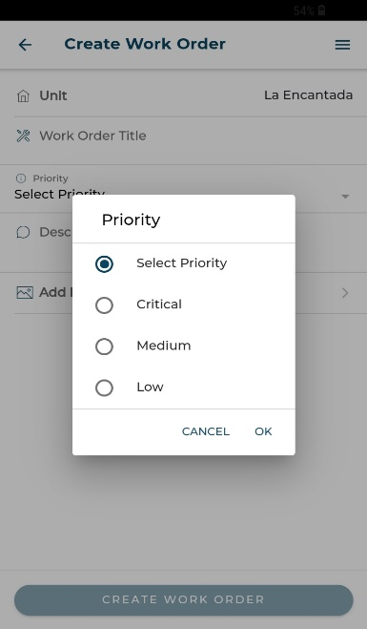  Figure 12: select priority | 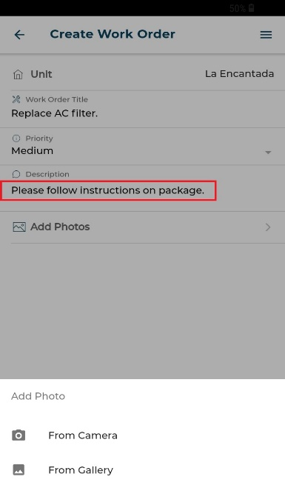  Figure 13: add description
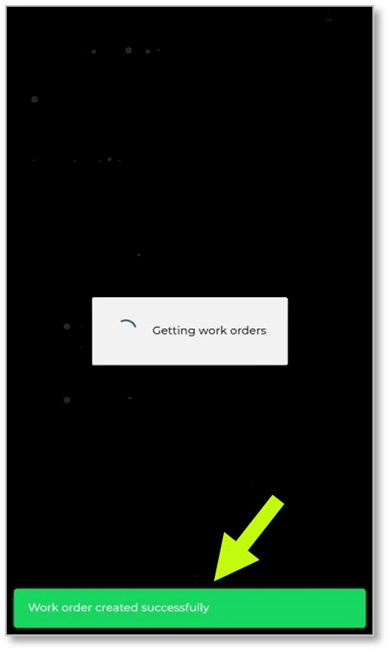  Figure 16: view confirmation | 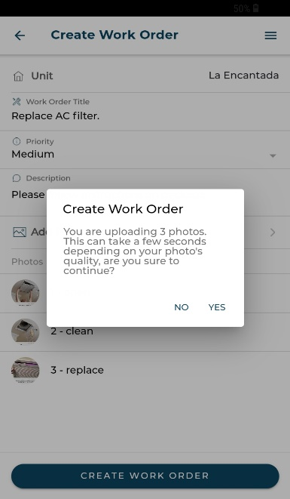  Figure 15: confirm details | 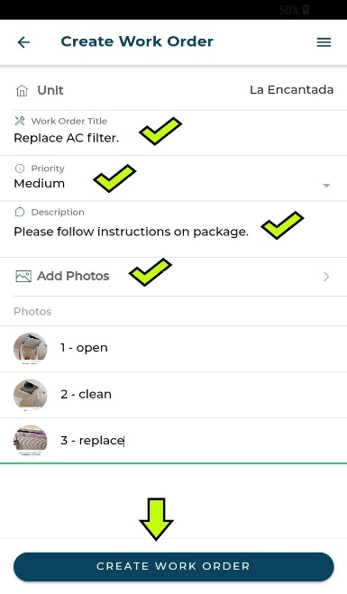  Figure 14: create work order

Reports

By accessing the Reports area, you will have access to the following:

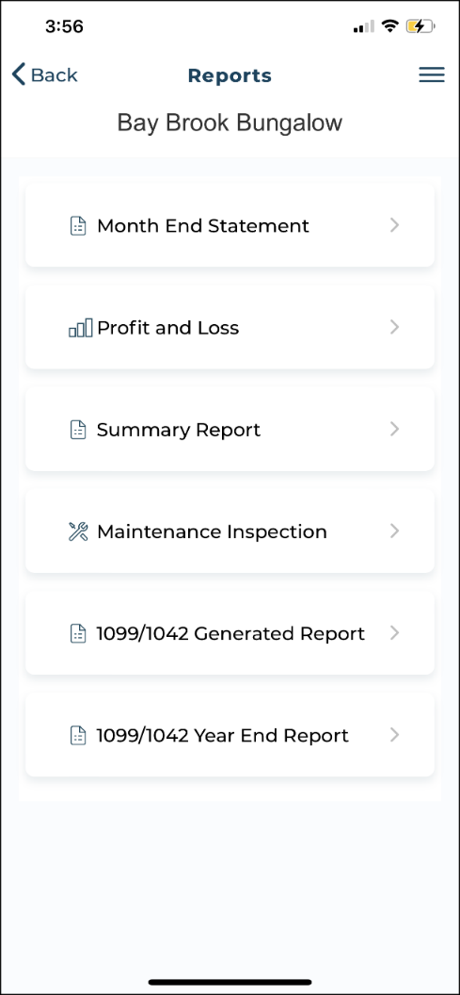
Figure 17: reports menu
Note: The Month End Statement will always show in this area. Depending on our system setup, other reports may not be available.

Month End Statement

- Selecting this tab will show all the month end statements available for the unit
- Select a statement to view (Figure 18 & 19)..

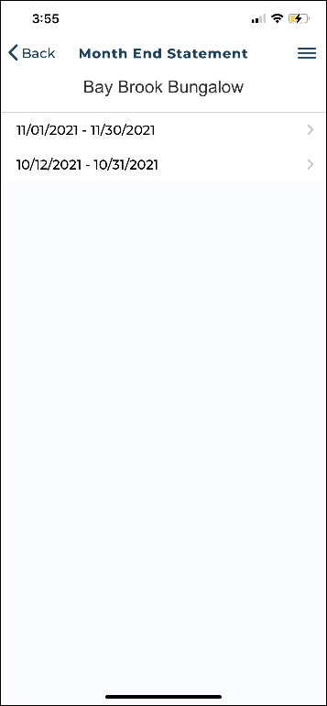  Figure 18: month end statement screen | 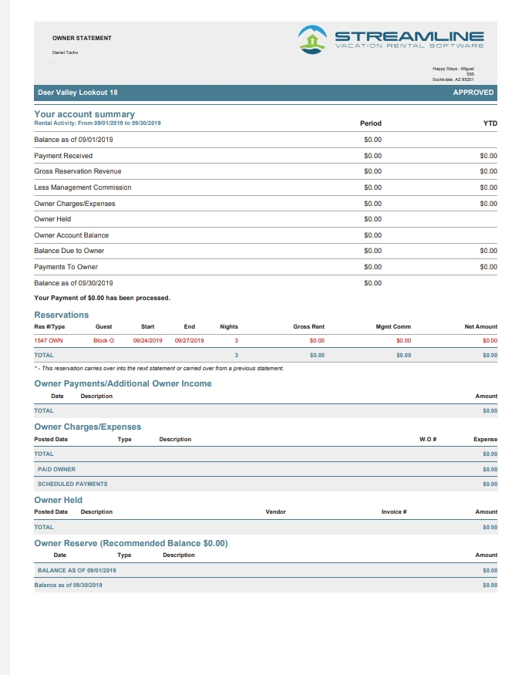  Figure 19: month end statement details

Profit and Loss

This report shows income and expenses by unit, by date range (Figures 20 – 22).
- Select the [Get Report] to generate the report.
- Select the [Download Pdf] to download the report in pdf format.

The report will include reservation data, gross room revenue, management commission, and the date, type, description, and amount of expenses. Also considered as Net Income.

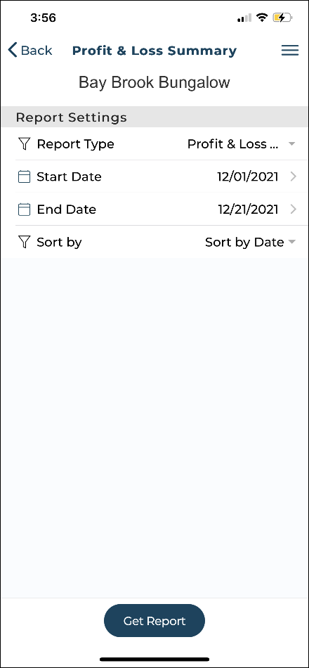  Figure 20: profit and loss screen | 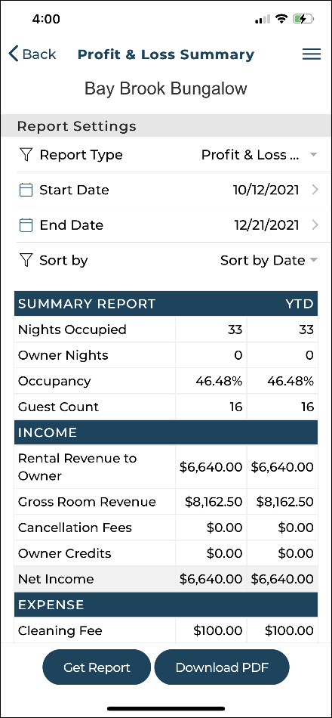  Figure 21: profit and loss summary | 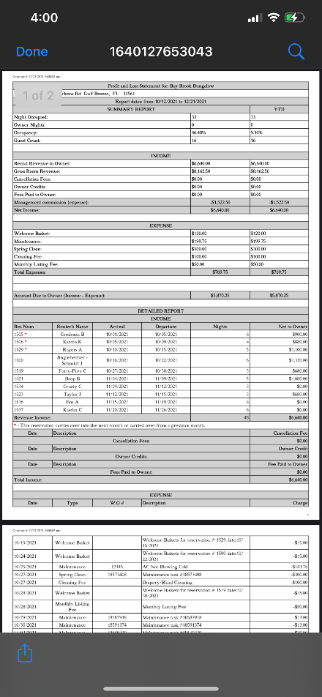  Figure 22: profit and loss report

Summary Report

- Selecting this tab will show options to generate the report.
- Choose to generate a summary report by reservation check-in, check-out, or creation date (Figure 24).
- Select the date range and [Get Report] (Figure 25).

This report will include the details of reservation type, date of arrival, number of nights, number of guests, rent, and owner commission.

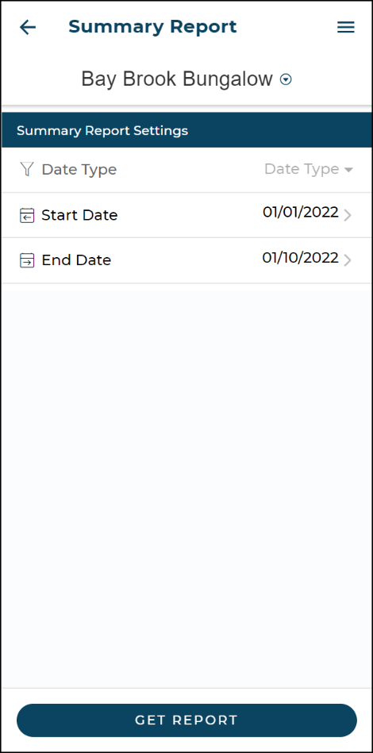  Figure 23: summary report screen | 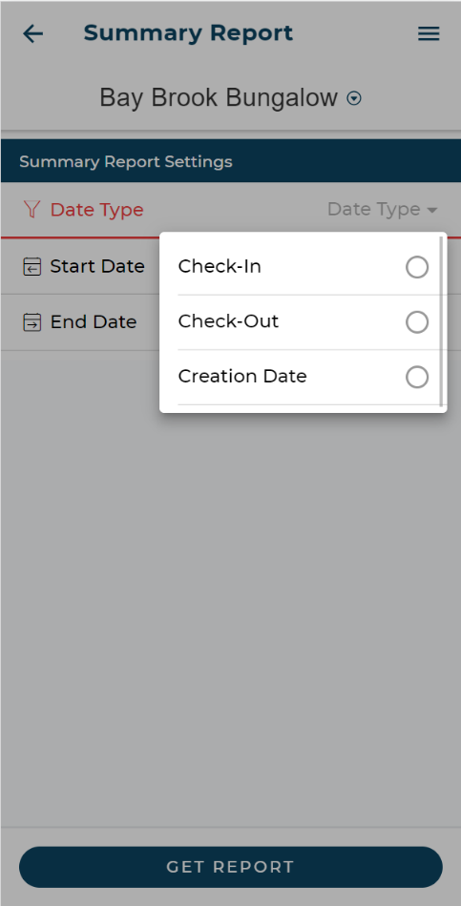  Figure 24: summary report settings | 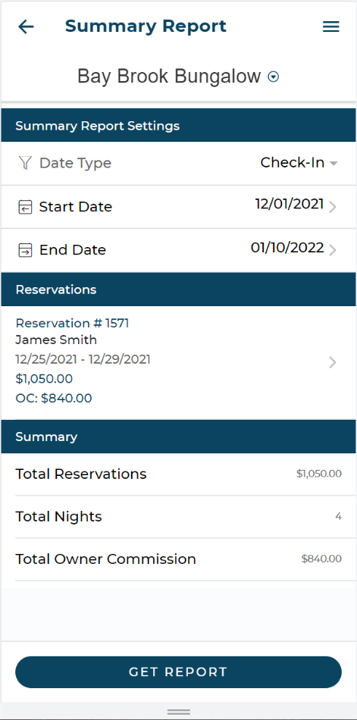  Figure 25: summary report

Maintenance Inspection

Maintenance inspections can be generated for a specific date range.

- Selecting [Get Report] will show details of maintenance inspections created within that date range for the unit (Figure 26).
- Select the download icon to generate and view the details of the maintenance inspection (Figure 27).

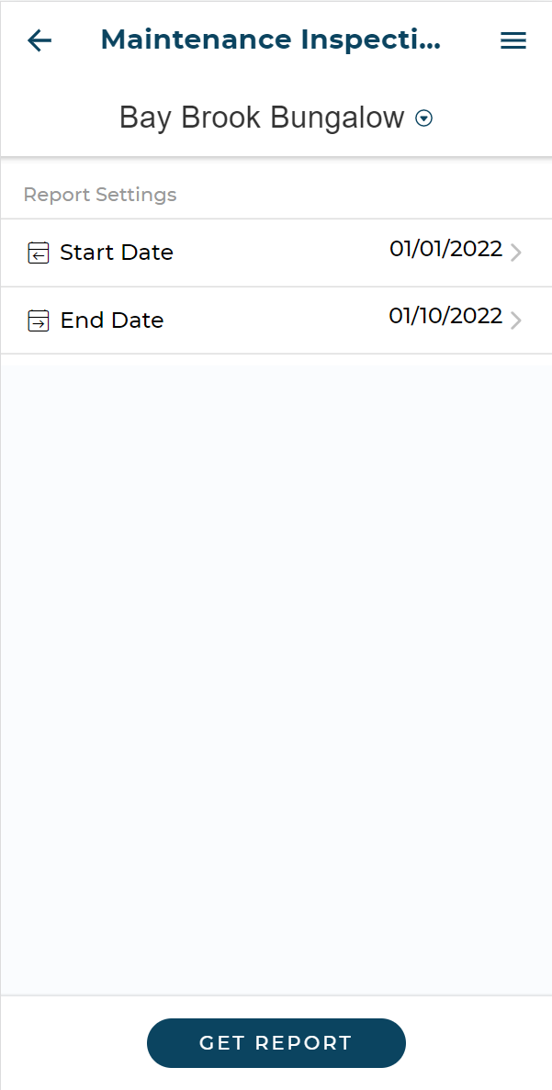  Figure 26: maintenance inspection screen | 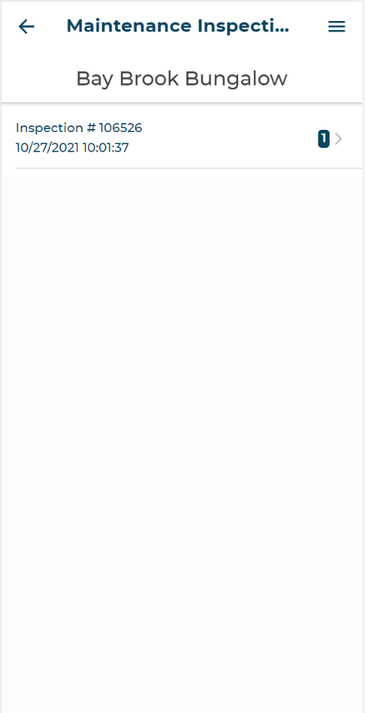  Figure 27: maintenance inspection report summary | 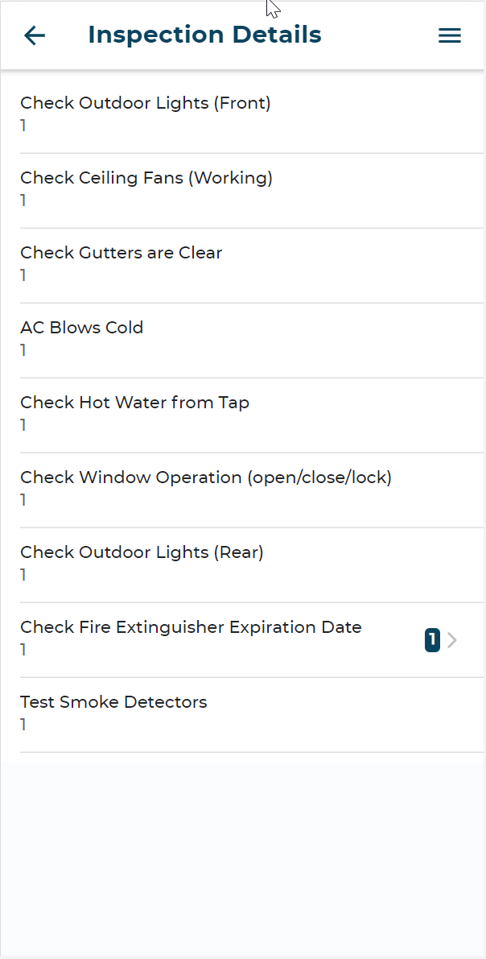  Figure 28: maintenance inspection report details

1099/1042 Generated Report

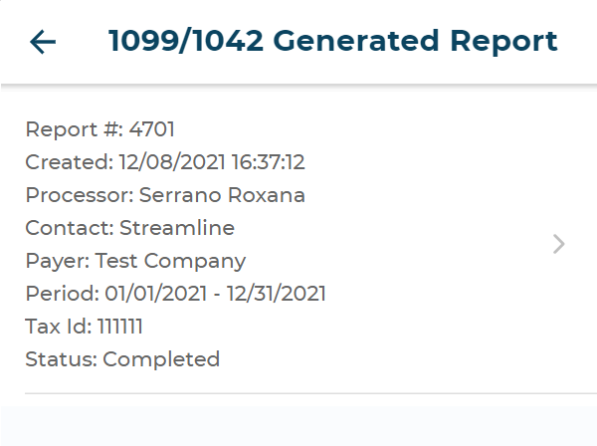
Select this tab to generate the 1099/1042 report
Figure 29: 1099/1042 generated report

1099/ 1042 Year End Report

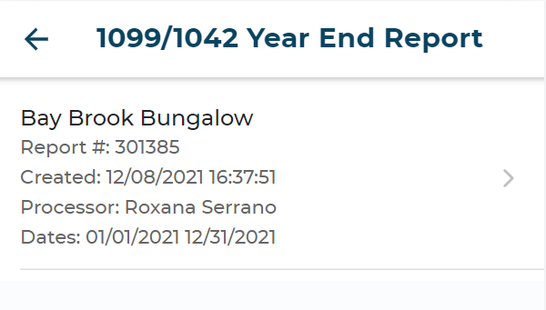
Select this tab to generate the 1099/1042 year-end report.
Figure 30: 1099/1042 year-end report

Service Tasks

Selecting this tab will show options to toggle and view [Open], [Closed] and [Deleted] (Figure 31) service tasks. You can also slide an Open task to choose the Close or Delete options (Figure 32). Slide a Closed task to choose Activate or Delete options (Figure 33).

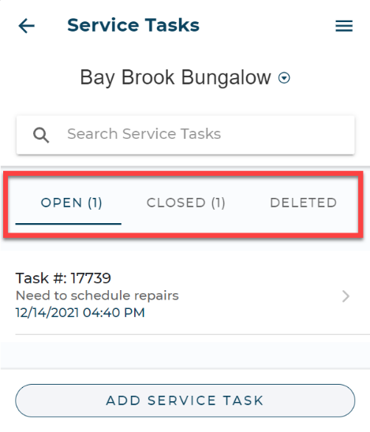  Figure 31: service tasks toggle options | 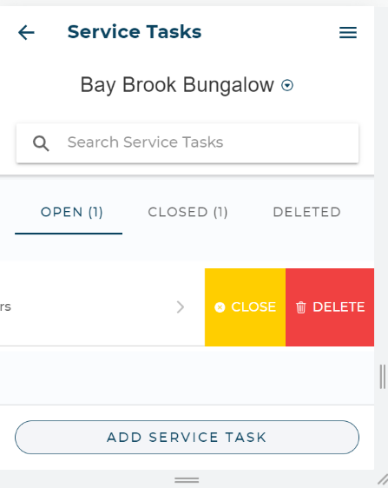  Figure 32: open tasks slide options | 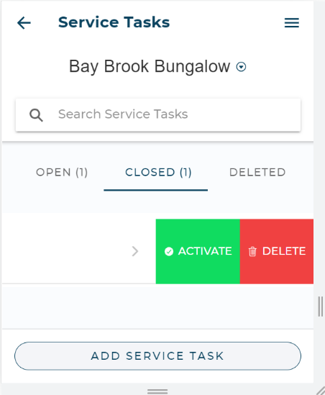  Figure 33: closed tasks slide options

Steps to Communicate with PMC for a Service Task

- Select the task to view the history and details of communications with the PMC regarding this task
- Send response using the message window at the bottom.
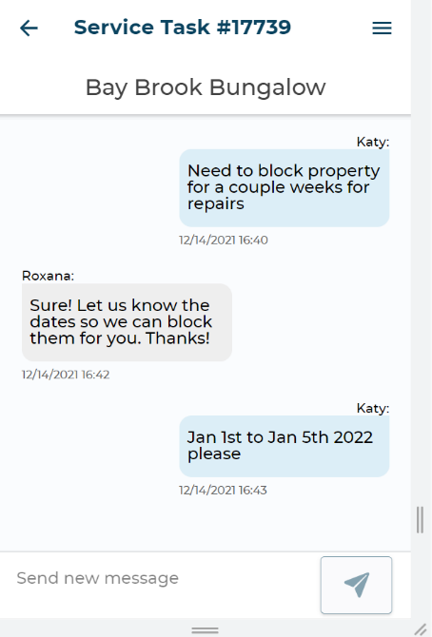
Figure 34: messages and response

Steps to Add a Service Task

- Select the [Add Service Task] button (Figure 34)
- Enter a Title for the task (Figure 35).
- Enter a Description for the task.
- Select [Create Service Task]

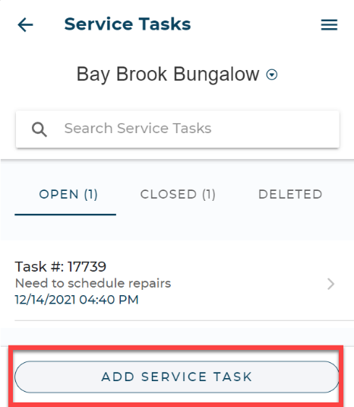  Figure 35: service task screen | 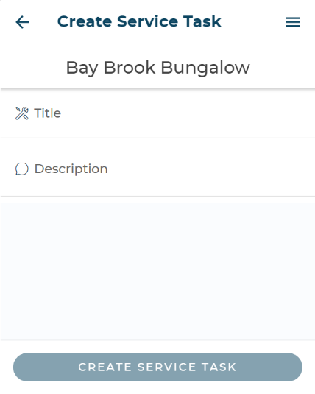  Figure 36: adding a service task

Attachments

This tab provides an easy method to share property documents with the PMC.

Steps to Add Attachments

- Select the [Add Attachment] button
Figure 37: Add Attachment button
- Select [Add File] to upload the document.
- Select the [Save Attachment] to save the document.

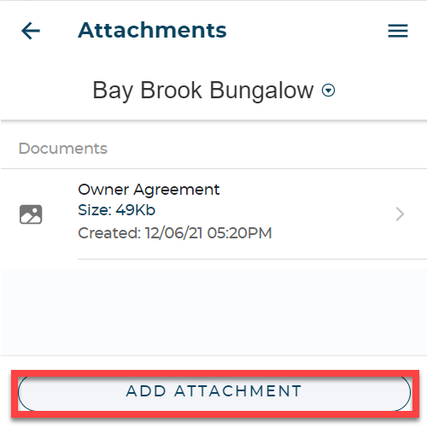  Figure 38: add attachment screen | 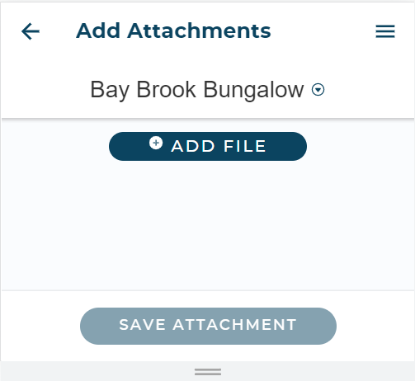  Figure 39: upload file

Steps to Download Attachments

- Select the arrow [>] next to the document details.
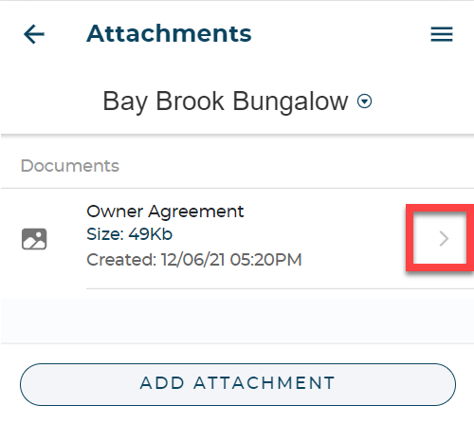
- Save the document.

More info

The More Info area presents an overview of the unit’s enabled Additional Property Fields.

MAKE RESERVATION

This option follows the same steps as provided under the section Steps to make Reservation (CTRL + Click the highlighted text to follow the link)

APPLY COUPONS AND DISCOUNTS

Follow these steps to apply coupons and discounts when making a reservation.
- Select [Make a Reservation].
- Select the unit.
- Select the reservation dates.
- Click on the dropdown menu under Coupons and Discounts tab.
- Apply the coupon/ discount.
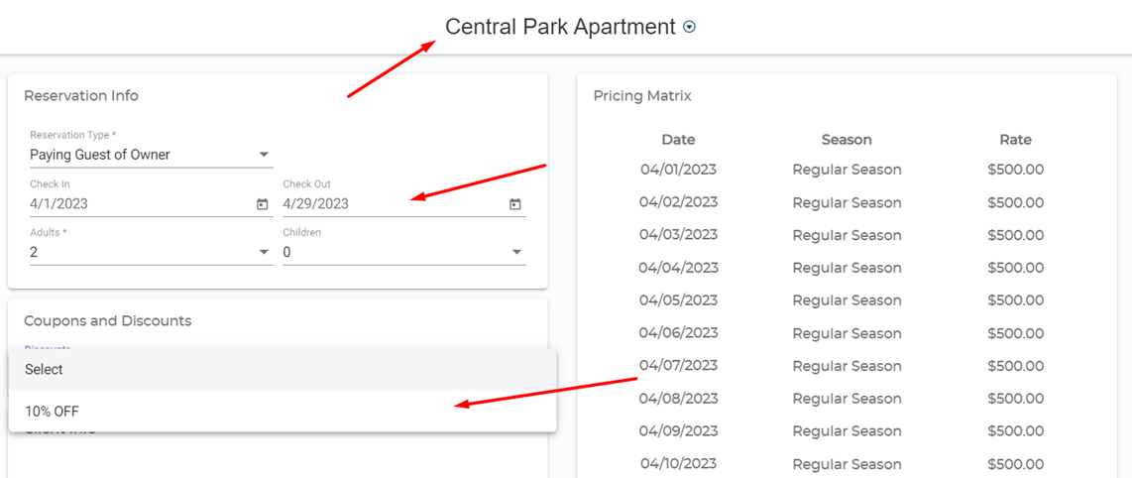

NEWS
The News area presents important information from us.
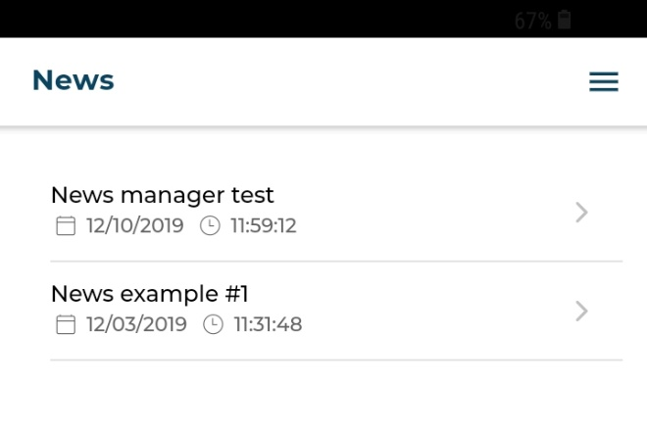
Figure 40: news screen

CONTACT US

In the Contact Us area you will be able to view our contact information:

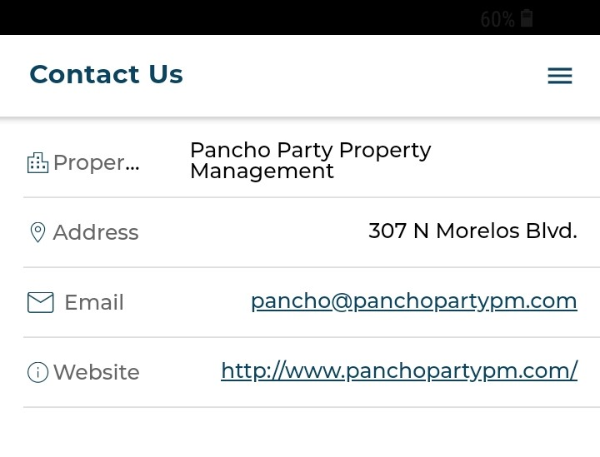

Figure 41: contact us screen

SETTINGS

In the SETTINGS area you will be able to
- View your own account information.
- Choose to view your taxes electronically.
  - Toggle on [Enable this to opt in to see your taxes electronically]
- Log Out of the App.

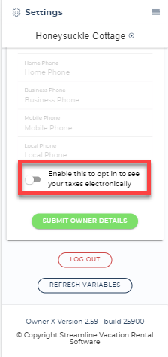

Note: Get in touch with us if you notice any information that needs to be changed.

